**Laboratory 15 ELISA Antibody Test**

**Purpose:**

The purpose of the ELISA Antibody Test is to detect and measure antibodies against bacteria, it could be viral or fungal infections. The antibodies are proteins that our bodies produce that help us fight against antigens.

**Procedure:**

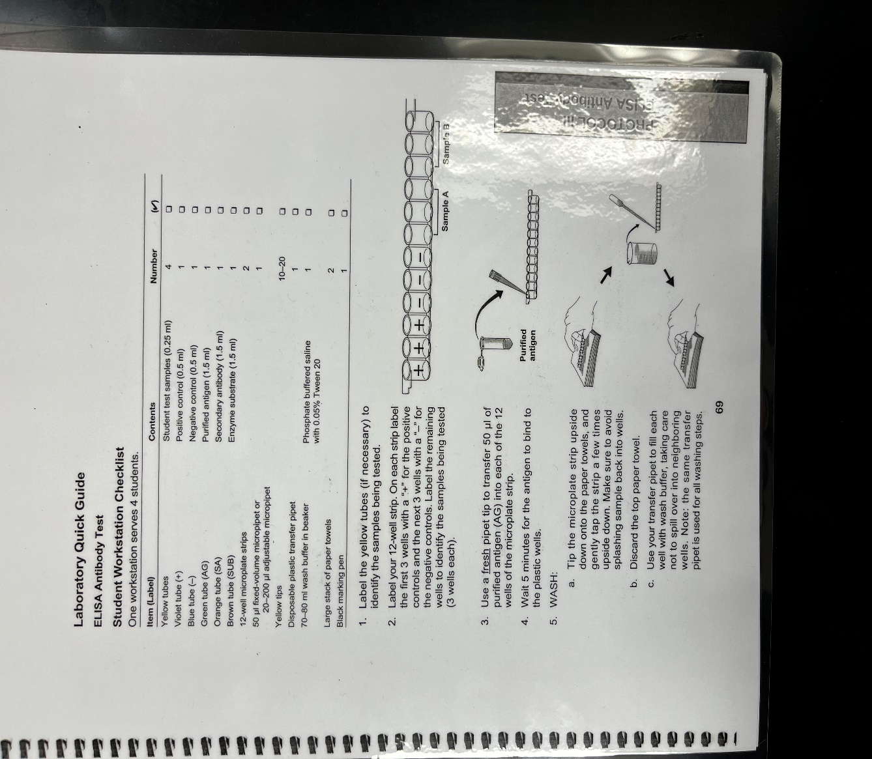

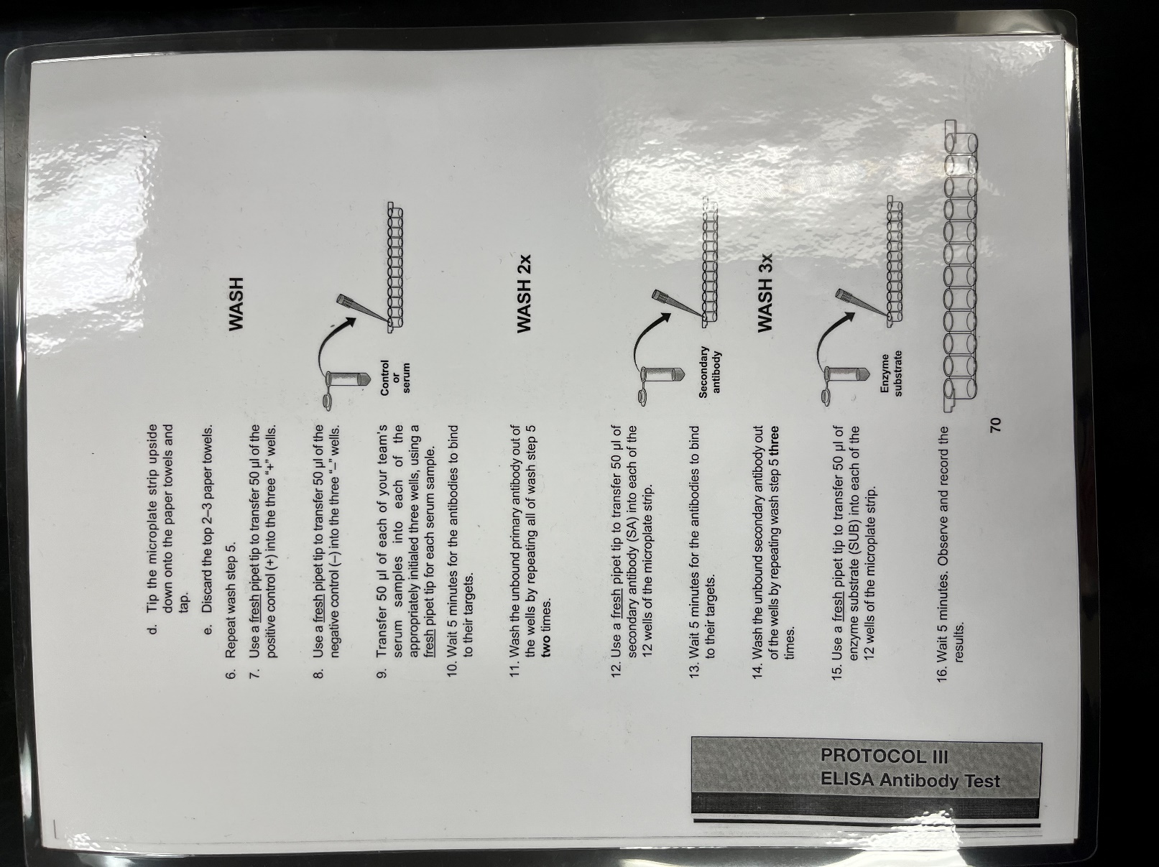

**Results:**

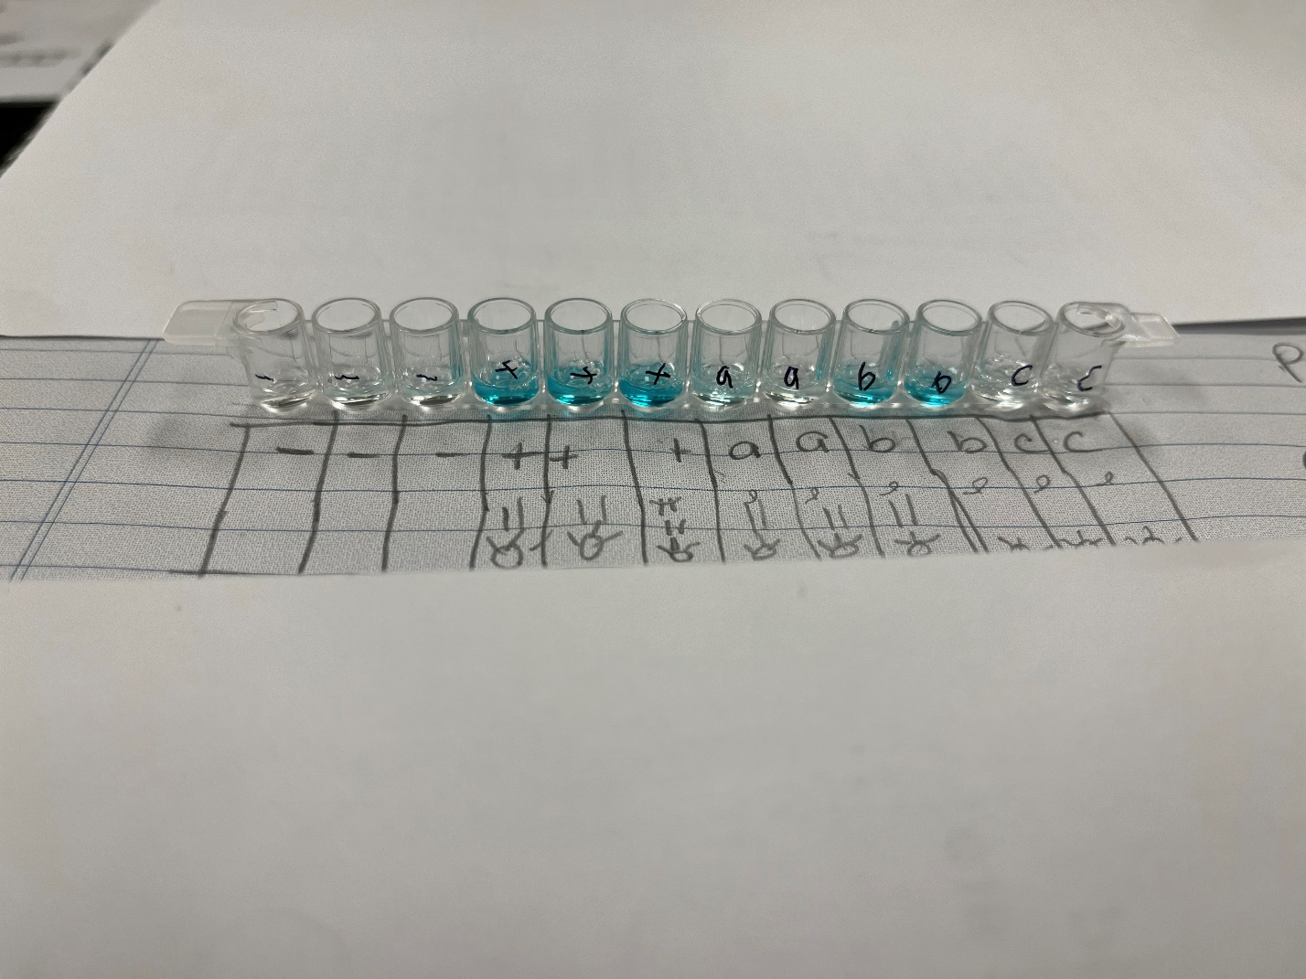

**Discussion:**

I enjoyed this activity, it required a steady hand in placing the purified antigen and the positive and negative control substance into each wells. As you can see from the photo above we accidently contaminated the first well of ‘a.’ Fortunetly all the other wells seemed to be good.

**Conclusion:**

I would do this experiment again. It was step by step informative and pretty simplictic to follow along with.